Court set to cut in line
Judge to determine how to break bipartisan snag in redrawing district lines
By Jimmy Vielkind

Published 12:19 a.m., Monday, February 27, 2012
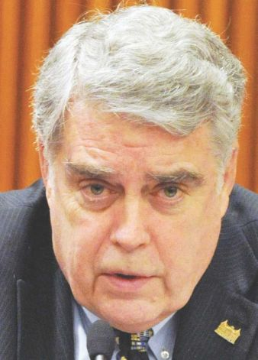
ALBANY — With a federal judge on Monday expected to determine how to get involved in the redistricting process, state officials said Sunday they still have not agreed on boundaries for the state's congressional representatives, whose ranks will be reduced by two.

A state task force called LATFOR, jointly controlled by Democrats who dominate the Assembly and Republicans who control the Senate by a bare majority, is in charge of drawing the district lines. Its partisan halves are tweaking lines for members of their respective state chambers, but have not reconciled proposals for Congress.

"There is no agreement yet on the Congress," said Albany Assemblyman Jack McEneny, LATFOR's Democratic co-chair. "I'm hoping that we can come to terms. If we can't come to terms, I don't know what will happen."

Senate Majority Leader Dean Skelos, R-Long Island, had said he expected a vote on the lines by Thursday. McEneny said the houses were close to agreement on a revised version of state legislative lines — the draft lines released earlier this month, particularly those for the Senate, have been roundly panned and condemned by Gov. Andrew Cuomo — which he hoped would be finished "this week."

Fearing Cuomo might veto their work, as he has threatened, LATFOR's members had hoped to pair the new state lines with the congressional maps. Now they seem to be waiting for a federal court to act: On Monday, Magistrate Roanne Mann will consider who should be appointed a special master to supervise the redistricting process.

The hearing arises from a suit by several voters who alleged LATFOR's continued inaction warranted judicial involvement. Another federal judge set the congressional primary for June 26, citing New York's non-compliance with federal voting requirements. The primary for state-level races remains set for Sept. 11.

"We're four months away from a court-mandated congressional election and don't know where the congressional lines are. It's unspeakably unacceptable," said Dick Dadey, executive director of good-government advocate Citizens Union. "You can't run a democracy when the voters and the candidates don't know the districts."

Speculation continued over what the congressional lines will look like, and which current representatives may be left without a chair when the music stops. Six members of the delegation have spent over $169,000 lobbying LATFOR, state records show.

Several officials and others with knowledge of the process indicated one of the seats might disappear near the border of Queens and Nassau County. There is a push to create another majority-Latino congressional district in upper Manhattan and the Bronx, which would cause an eastward shift that would eventually drive Rep. Joseph Crowley deeper into Queens, and as a result squeeze other representatives.

The New York Daily News has reported that this would pit Reps. Gary Ackerman and Carolyn McCarthy, both Democrats, into a primary against each other. On Saturday, two sources indicated Ackerman had discussed his retirement, something the 69-year-old congressman denied via Twitter, blaming a "Republican rumor mill."

On Sunday, New York City Councilman Ydanis Rodriguez led a march of 100 people from the northern Manhattan neighborhood of Inwood into the Bronx, arguing for an additional seat. The area is currently represented by Rep. Rep Charlie Rangel, an African-American Democrat from the Manhattan neighborhood of Harlem.

"The Senate Majority Leader has said publicly that he's open to creation of the district," said Rodriguez, a Democrat. "We feel that there's momentum in our community demanding the creation of a third Latino congressional seat, based on the numbers that we have in the city."

A spokesman for Sen. Mike Nozzolio, LATFOR's Republican co-chair, declined to comment. McEneny did not tip his hand about the congressional lines.

"Everything is being considered. We haven't come to terms yet," he said.

AD-104

